**How to run renumber.py**

* Make a copy of the xml file from Github and save it locally on your computer in the same folder as renumber.py. This is so if you accidentally mess things up, at least you will have the original in Git to go back to.
* Rename the file asdf.xml (or any other name you like—this is just the convention I use)
* Open renumber.py in Sublime
* Edit line 6 so that the numbers represent the range you wish to change. So, for example, if I wanted to change all line numbers so that lines 1411 and onward go up one number, I would type in:
  + for x in range(1615,1411,-1):
* The first number (1615 in this example) lets the script know when to stop numbering, so it should be greater than the last number in the document. The second number is where you want the renumbering to start. For example, if line 1412 is missing and you need to shift all subsequent numbers up one, type in 1411. (1411 in this example).
* If you have renamed the xml file anything other than asdf.xml, edit the lines 3 and 9 to represent that change.
* Save the file. This is important (and often forgotten!).
* Open the terminal (Mac users, I don’t know what Windows users do here).
* In the command line, type cd (change directory) and then the directory path to the folder you are using. For example, on my computer I store the python script and xml files in Documents/UW/RCLM/Harley:
* 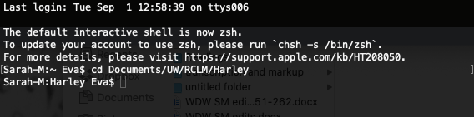
* Your command line should now represent that change in directory.
* Next type in “sudo python renumber.py”. Basically, “sudo” is the command that tells the computer to do an action, “python” tells the computer what language to use, and “renumber.py” tells the computer which file to run.
* Press Enter. The terminal will ask for your password. If you are the administrator on your computer (you most likely are) this is the password you use to log on.
* For example: 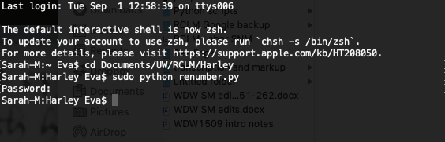
* The script has run! Now open the asdf.xml file and check to make sure everything ran correctly.
* There may be duplicate numbers. In this example I ended up with two lines numbered 1413 right in a row, because there were two lines numbered 1412 before running the script. That’s an easy fix.
* You may also need to change the n=”[number]” for subsequent lines if that has already been done.
* Open the collaborative file from GitHub. Now copy and paste the renumbered lines from your local asdf.xml file over the respective lines in the collaborative file in GitHub. This part is always terrifying and I check to make sure I have the correct section highlighted several times before pasting!
* Check to make sure you have transferred the correct lines over and all is well **before saving**. If you have made an error, simply close out the collaborative file without saving (and without subsequently pushing to GitHub). Reopen the file from GitHub and try again.
* Once all is well save the collaborative file and push it to GitHub.
* Congratulations! You are now a terminal wiz!